- Write a C program to simulate a Deterministic Finite Automata (DFA) for the given language representing strings that start with a and end with a.

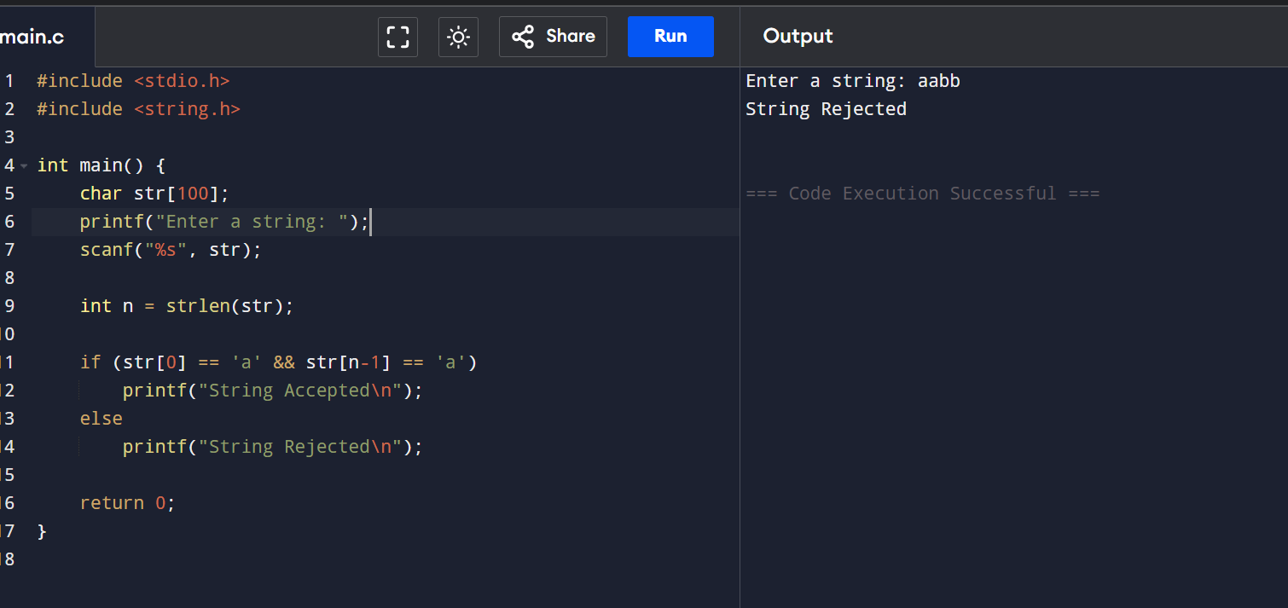

- Write a C program to simulate a Deterministic Finite Automata (DFA) for the given language representing strings that start with 0 and end with 1

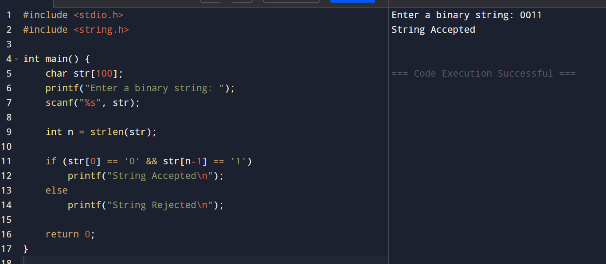

- 3 Write a C program to check whether a given string belongs to the language defined by a Context Free Grammar (CFG)
S → 0A1 A → 0A | 1A | ε
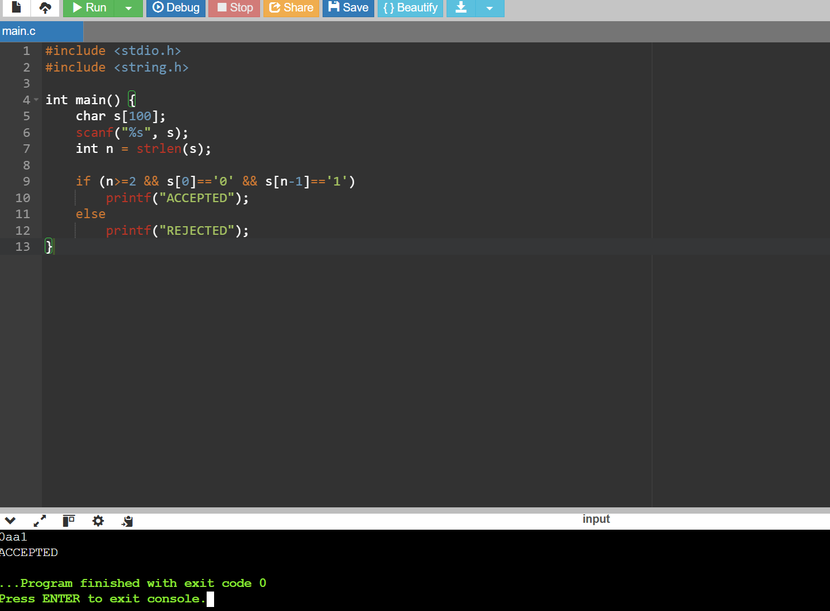

- 4. Write a C program to check whether a given string belongs to the language defined by a Context Free Grammar (CFG)
S → 0S0 | 1S1 | 0 | 1 | ε

- 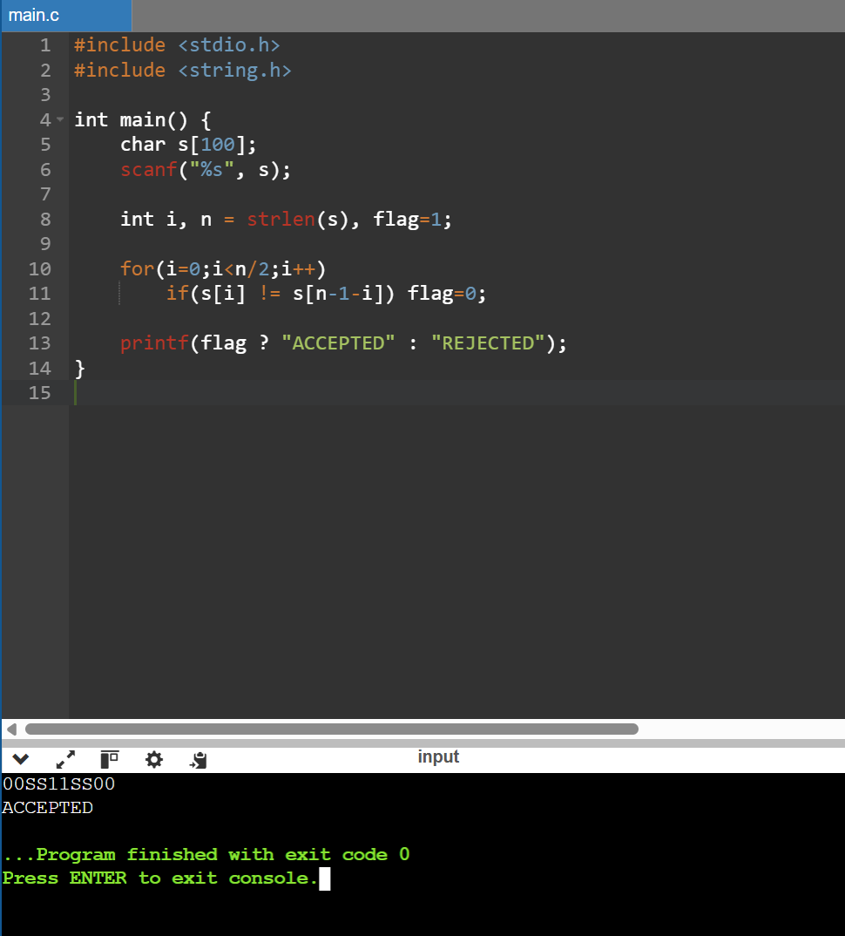

5 Write a C program to check whether a given string belongs to the language defined by a Context Free Grammar (CFG)
S → 0S0 | A A → 1A | ε

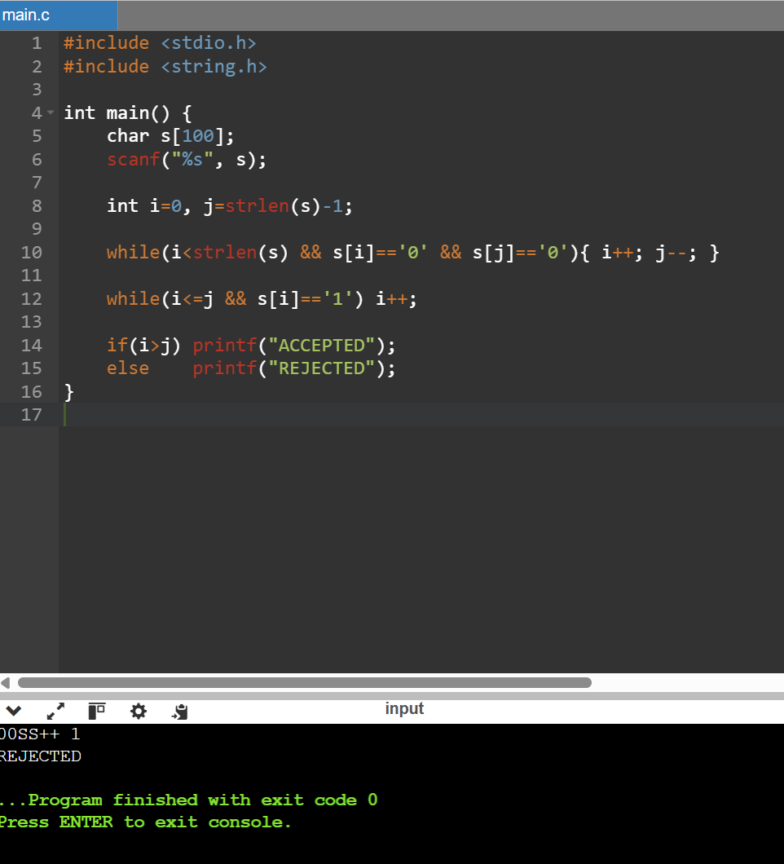

- Write a C program to check whether a given string belongs to the language defined by a Context Free Grammar (CFG)
S → 0S1 | ε

6 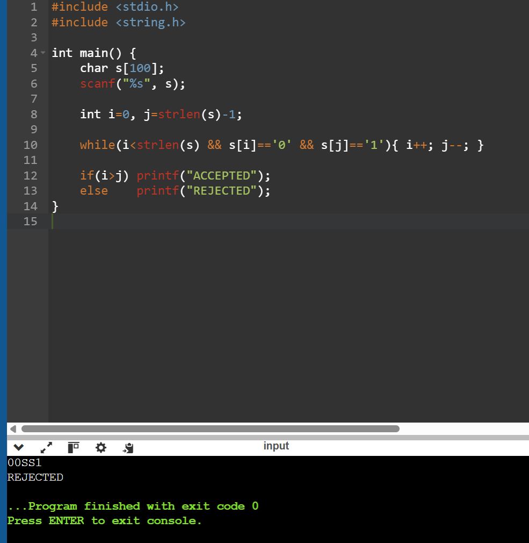

- Write a C program to check whether a given string belongs to the language defined by a Context Free Grammar (CFG)
S → A101A, A → 0A | 1A | ε
- 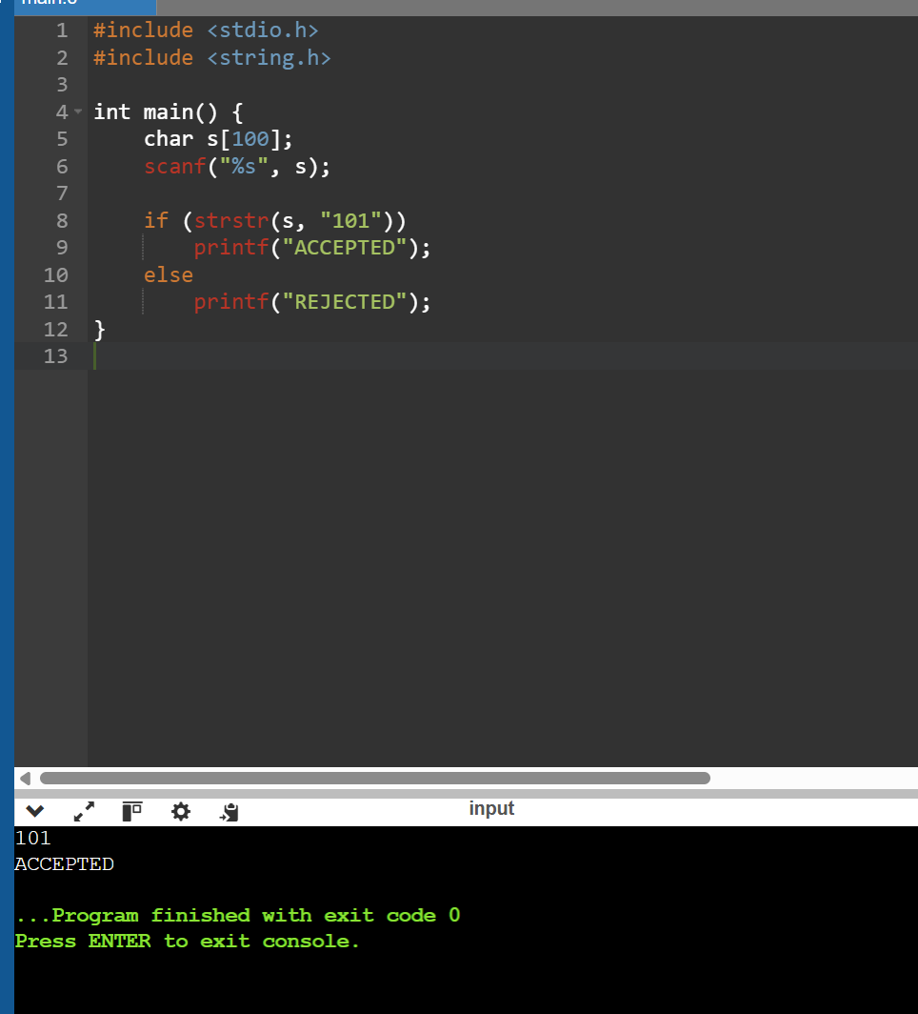

8 Write a C program to simulate a Non-Deterministic Finite Automata (NFA) for the given language representing strings that start with b and end with a
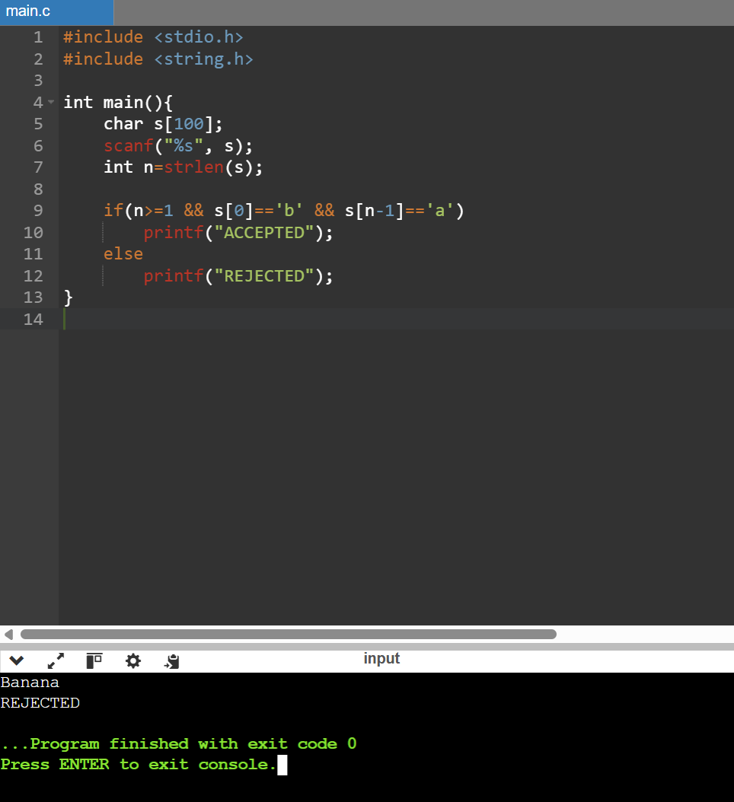

- 9 Write a C program to simulate a Non-Deterministic Finite Automata (NFA) for the given languagerepresenting strings that start with o and end with 1
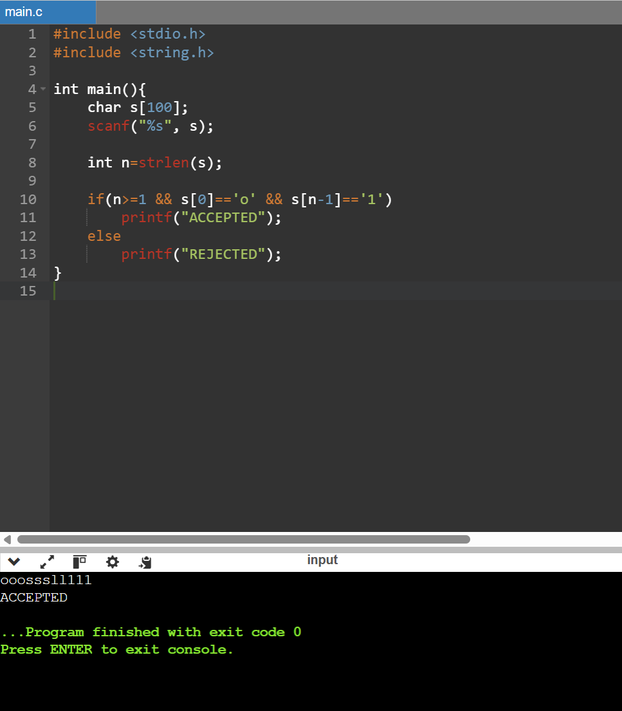

- 10. Write a C program to find ε -closure for all the states in a Non-Deterministic Finite Automata (NFA) with ε -moves.
